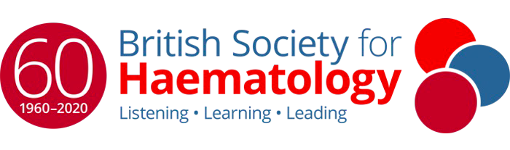

Call for Morphology Cases 2024

The 64th British Society of Haematology Annual Scientific Meeting, Liverpool, invites you to submit morphology cases for presentation.

BSH Annual Scientific Meetings provide a fantastic opportunity to showcase your research and share your expertise with colleagues, peers and fellow participants.

Please send 1-2 photographs and a short synopsis of the case by 30th November 2023 to Alesia Khan, HMDS (Haematological Malignancy Diagnostic Service) Leeds, via email alesia.khan@nhs.net for a shortlisting process.

Submissions received after this date will not be considered.

Important dates:
- Submission for morphology cases opens on 1st November 2023
- Submission for morphology cases closes on 30th November 2023
- Notification of the outcome of submission on 15th December 2023.

Please include:
- Your name, centre and contact email address.
- If you will be available to prepare the presentation and deliver as the ASM, or would like someone to present on your behalf.
- Patient demographics
- Full blood count
- Short clinical history
- Additional investigations and results relevant to the case.
- That you would be able to post glass slides for scanning to the Leeds Virtual Pathology website to be viewed by candidates and be part of a valuable teaching resource

Please ONLY send glass slides including any or combination of if your case is selected for presentation.
- Blood film
- Aspirate
- Trephine
- Special stains & immunohistochemistry
- Lymph nodes or other tissue.

Technical details:
- If the slides are not cover slipped then no need to do this, we will do it.
- Please do not send the only slide available for the patient. Diagnostic material should remain in the referring centre, and the slides sent should be duplicates /spares.
- PLEASE TAKE THE PHOTOS FOR YOUR PRESENTATION PRIOR TO SENDING THE SLIDES.
- If you do not have the ability to take high definition photographs of the morphology for the presentation then please let us know and we may be able to do this for you.
- Do not include IDENTIFABLE PATIENT DETAILS – these should be removed from the slides.

Cases will be considered for presentation, and you will be notified of the outcome by 15th December 2023.

The presentation should be MAXIMUM 8 minutes in duration, including the morphology photographs, a mix of clinical and laboratory data and allow for interaction with question via Slido or similar. During the 8 minutes it will be useful to build the case by providing additional information. We can provide support and assistance for this if you require.

If your case is chosen for presentation, then your BSH ASM registration will be arranged. If you are unable to attend in person to present the case then we will be able to present on your behalf.

Thank you for your cases. We look forward to reviewing them & enjoying the presentations. Your contribution will be fully acknowledged and certificate can be issued on request.

